**Geographical Information Systems**

**Assignment 4**

|  |
| --- |
| **Student Name:** Mohamed Samy Mahmoud Elgabry |
| **Student ID:** 20190441 |
| **Group No.:** S1 |

**Create an arc toolbox called “my first arc toolbox” contains the following models and tools.**

**Exercise 1: Create a tool to obtain a feature class with preclusive areas.**

**Exercise 2: Create a tool to obtain a feature class with unfavorable areas**

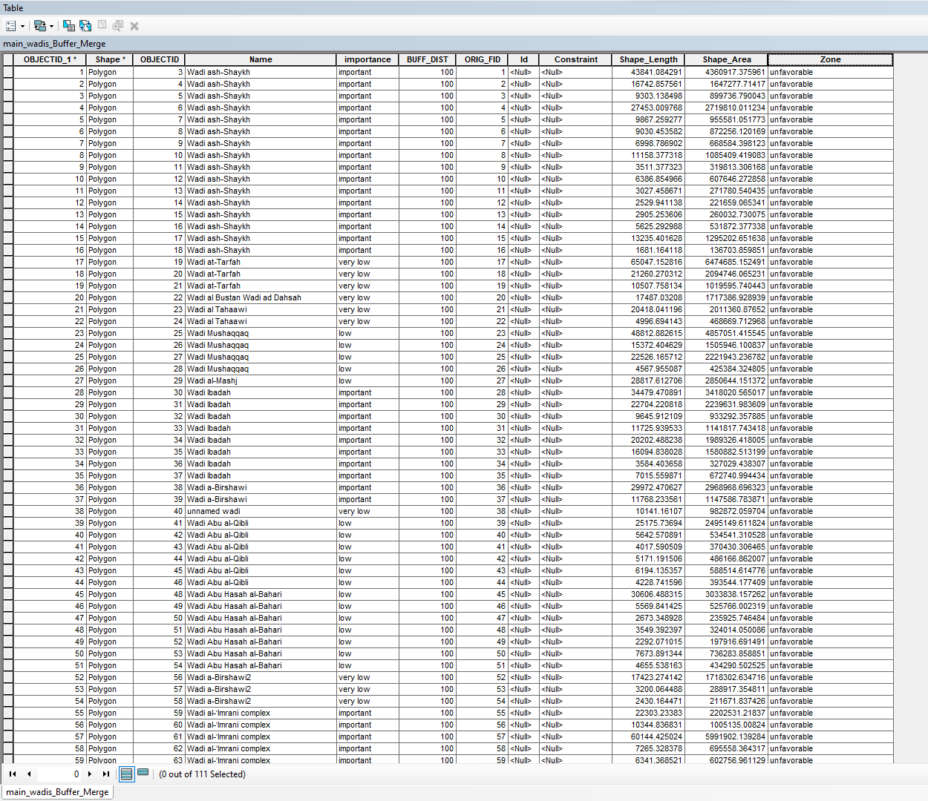

**Exercise 3: Integrating a model within a model Create a tool to obtain a feature class with all preclusive & unfavorable areas:**



